Phase 4

Day 1 :

05-15-2023

HTML, CSS, JavaScript(ES5 and ES6), Bootstrap, React JS and Mongo DB

https://[www.google.com](http://www.google.com) URL

req(http/https)---🡪

Client Server

🡨--res(http/https)------ HTML/HTML5

HTML : Hyper text mark up language. Which provide lot of pre defined tags or elements which help to develop the web page.

Using html we can develop static as well as dynamic web page. Dynamic web page we can create from html4/html5.

VSCode

<tagName> opening tag

</tagName> closing tag

If we write anything but file extension must be .html or .htm then it is consider as html code.

In html 4 version

<!doctype html public url=[www.asfafafasd.dtd](http://www.asfafafasd.dtd)/>

Document type definition file contains the rules for the html page

What is the root tag name, that tag contains how many child tags, tag mandatory or optional.

In html 5 they remove these rules they introduce new tags to make html dynamic.

<!doctype HTML>

CSS : Cascading Style Sheet

Attribute : Attribute is known as properties of tag. We can use attribute in the form of key-value pairs and attribute must be use in opening tag.

<tagName key1=”value1” key2=”value2”></tagName>

CSS provided lot of pre defined properties which help to apply formatting style for web page.

Using CSS we can make separation of concern.

Means actual content and formatting style we can write separately.

Types of CSS

1. Inline CSS

<tagName style=”property:value;property:value;”></tagName>

1. Internal or embedded CSS

In this type of css

We need to use css rules inside style tag and that tag must be in between head tag

<style type=”text/css”>

Selector {property:value};

</style>

1. Universal selector : *
2. Specific selector : tagName{property:value}
3. Local Class selector : tagName.className
4. Global class selector .className
5. Id selector : #idname

Class selector Vs Id selector

Class attribute : group of tags which have same name or different name we need to add class.

Id attribute : using id attribute we can make uniqueness between two tag which have same name or different name.

1. External CSS

Global css rules

We need to create external css file with any name with extension .css and write more or more rules with different types of selector and this file we need to include in every html page with help of link tag.

Box Model :

Day 2 :

05-16-2023

Bootstrap : Bootstrap is an open source front – end web css framework. Bootstrap is first css framework which help to create responsive web application.

Mobile, tab, desktop etc.

If we develop any responsive web application the application alignment arrange according device with and height.

We will see first responsive web page using html5 features.

Bootstrap provided external CSS library or files which contains set of pre defined css classes with respective all html tags like div, p, h1 to h6, form, table etc.

If we want to apply bootstrap features to our application

1. We need to download external bootstrap file and add in our application (offline)
2. We need to link bootstrap url (CDN) path.
3. We can download using node js.

Button classes

Btn-success

Btn-primary

Btn-secondary

Etc

Container classes

container and container-fluid : these two classes generally we use with div tag.

Alert : Alert is use to display contextual feedback message on web page.

Table classes :

Bootstrap Grid layout :

Bootstrap grid layout helps to arrange the component in html page in table format ie using row and columns.

Using grid layout only we can arrange component alignment base upon device width.

In Bootstrap grid layout each row by default divided into 12 columns.

Device size width

<576 px extra small

>=576 px small

>=768 px medium

>=992 large

>=1200 extra large

>=1400 double extra large

Day 3 :

05-17-2023

JavaScript :

JavaScript was known as object based interpreter scripting language till EC5 JS.

But from EC6 onward JavaScript known as object oriented scripting language.

Till ES5 JavaScript was not supporting class concept. It provided lot of pre defined object as well as we were/are creating user defined object using functions.

Till ES5 JavaScript was known as object based or prototype base.

But from ES6 onward JS support object, class from EC6 we can say JS also object oriented scripting language.

ES : ECMA (European Computer Manufacture Association)

ES is a concept. One of implementation of ES is JavaScript.

Using JavaScript we can do programming on web page without Server.

If we want to do JavaScript code in html we need to use script tag.

Syntax

<script type=”text/JavaScript”> opening tag

We can do programming

document.write(“Welcome to JavaScript”);

</script> closing tag

This tag we can write in between head or body tag of web page.

document is a pre defined object and write is a pre defined function.

JavaScript is care sensitive. We need to write in lower case.

Variable : In JavaScript we can declare the variable using var keyword till ES5.

From ES6 onward we can declare the variable using let as well as const keyword.

Syntax

var variableName;

Data Types : in JavaScript data types are divided into four types.

1. Number type
2. String type
3. Boolean type
4. Object reference type

JavaScript is known as loosely data type scripting language.

var a; document.write(a); default value is undefined.

var b =10; it consider as number type data type

var c=10.20; it consider as number type data type.

var name = “Ravi Kumar”; it consider as string type

var result=true; it consider as boolen type

var obj = new Date(); it consider as object reference type.

Operator :

Arithmetic Operator : +, -, *, /, %

Assignment Operator : =

Conditional operator : >, >=, <, <=, ==, ===

Logical operator : && , !, ||

Ternary operator : condition ? true block : false block;

Typeof operator or function:

If statement

If else

If else if

Switch statement

Looping

While loop

Do while loop

For loop

Function : function is use to write set of instruction to perform specific task. Function like a method in java.

In JavaScript function are divided into 2 types.

1. Pre defined function
2. User defined function

Pre defined function

1. alert(“Msg”): This pre defined function is use to display pop message.
2. prompt(): This pre defined function is use to take the value through keywords.
3. parseInt()
4. parseFloat()
5. eval()
6. confirm() : this function is use to take the confirmation from user. If we click ok it return true else it return false.

User defined functions

1. normal function declaration syntax

function functionName(parameterList) {

}

1. function no passing parameter and no return type.
2. Function passing parameter and no return type
3. Passing parameter and return type.

JavaScript Event :

Event provide bridge between HTML and JavaScript or event is an interaction between user and html components.

JavaScript provided lot of pre defined event and all those event start with pre fix on followed by event name

Example

onClick : button

onDblClick : button

onMouseOver : image or p tag or any tag

onMouseOut image or p or any tag

onKeyUp : text field

onKeyDown : text field

onSubmit : submit button with validation

onChange : drop down

onFocus : enter inside text field

onBlur : exits from text field

onload : when page load or refresh

onUnload : when page close

JavaScript object

Object : object is any real world entity.

Person

Bank

Animal

Car

Person

Every object hold two thing one is property and behaviour.

In JavaScript object are divided into two types.

1. Pre defined object
2. User defined object

Pre defined object :

JavaScript follow object hierarchy

Object --🡪 property (variable )

Behaviour (functions/methods)

Object -🡪 property

Behaviour

Object --🡪property

Behaviour

Object

JavaScript provided two pre defined object hierarchy

BOM : Browser Object Model

DOM : document object model

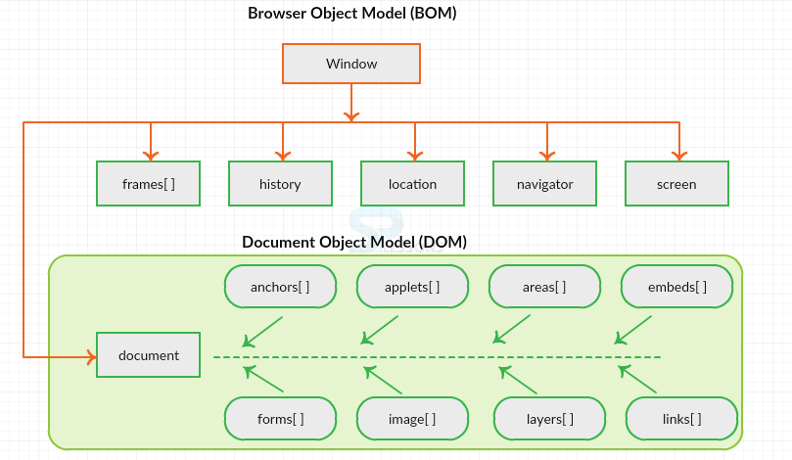

DOM Hierarchy

Internally in browser memory dom hierarchy will generate

Index.html

Html -🡪 root tag

Head body

Title div welcome (textNode)

Meta p

DOM API (Document Object Model – Application Programming interface).

Lot of programming language like java, python, C#, javascript provided lot of pre defined function or methods which help to read, write and update html content (DOM contends) dynamically.

Html tag also known as dom element.

Day 4 :

05-18-2023

document.getElementsByName(“name”)[indexPosition”].value;

or

document.getElementById(“idName”).value;

external JavaScript programs

if we write the code external javascript that code we can import in every html page with the help of src attribute.

DOM Operation Creating HTML tag with dynamic value using events

**ES6 JavaScript as well as ES5**

1. From ES6 onward to declare the variable in JavaScript we can use let as well const keyword.

Using var we can declare same variable once again with same value or different value. (re declaration)

var a=10; // int a=10; In Java

a=20; initialization //a=20;

var a=30; re-declaration // int a=30;

using let we can’t do redeclaration

let b=10;

b=20;

let b=30; // error in this line

using var we can declare global scope but using let we can declare local or block scope.

1. Types of functions
2. Normal function
3. Expression style function
4. Arrow function : arrow function extension version of expression style function without function keyword.
5. Callback function : passing the function name or function body or function itself to another function as a parameter is known as callback function.

Expression style function we need to use return keyword if we want to return any value. But in arrow function it return the value without return keyword.

Day 5 :

05-19-2023

JavaScript basic pre defined object

Array

String

Math

Date

Set :Set is pre defined object which provide lot of pre defined method

Which help store the data. Set doesn’t allow duplicate.

Map : We can store the data in key-value pairs.

Array object : In JavaScript array is type of pre defined object which allow to store more than one value of any type. Array object provided lot of pre defined method which help to add, remove, search, iterate elements from array very easily.

User Defined object creation

In JavaScript we can create user defined object in 3 ways.

1. Literal style :ES5 features
2. Function style : ES5 feature
3. Class style : ES6 features

Literal style object creation.

Object ; any real world entity

Property

Behaviour

Person

Bank

Animal

Car

Customer

Base upon Literal style JSON came in picture.

JSON (JavaScript Object Notation).

According to JSON information must be store in key-value pairs.

In JSON key must in double quote and value can be number, string type, Boolean, array object or complex object type.

If we want to share the data between two technologies like Java, python, asp.net, php, angular or react js.

To work with JSON javaScript introduce

JSON pre defined object. Which contains set of method which help to convert JS object into json and vice-versa.

Day 7:

05/22/2023

User defined object creation in function style

Every object contains property and behaviour

Employee

Customer

Car

Bank

function Employee() {

this.id = 100; // id is consider as instance variable.

this.name =”Ajay”;

this.age = 21;

this.displayEmpInfo =function{

document.write(“Employee object function”);

document.write(“Id is “+this.id);

document.write(“name is “+this.name);

document.write(“age is “+this.age);

}

}

Employee(); now it behave life a normal function

var emp1 = new Employee(); now Employee function behave like object.

document.write(“id is “+emp1.id);

document.write(“age is “+emp1.name);

document.write(“age is “+emp1.age);

emp1.displayEmpInfo();

In ES6 we can use class keyword to create user defined object

class Employee {

variable

function

}

ES6 support constructor :

Constructor is a type of special function which help to create the object.

In JavaScript to create or write a constructor we need to write function with name as constructor.

Constructor no need to call it will call automatically when we create object.

But any function which is a part of class we need to call explicitly using object.

React JS

In JavaScript DOM (Document Object Model ) is very important.

Read, Write and Update DOM Using JavaScript become more complex.

jQuery : jQuery is third party library which provided lot of pre defined function which help to read, write and update DOM very easily. We need to download jQuery external javascript file or using internet we need to link jquery external js file and use pre defined function to read, write and update DOM every.

When we move from one page to another page whole dom get loaded again and again which effect the performance

SPA (Single Page Application). According to SPA rather than loading whole page we can load only part of the web page and do the operation on that page according our requirements.

There are some JavaScript framework or library came in picture which support SPA.

React JS is a third party library provided by facebook which support SPA features.

React JS support Virtual DOM.

Angular also support SPA features.

Angular is a framework. Angular heavy framework. But react js a library and light weighted.

Angular is a part of Google organization.

React is a part of Facebook.

React with Redux

Angular following MVC architecture framework

But react is only View in MVC.

First React Application Using online Editor

Code Pen.

React JS provide two pre defined module or library ie

React

This module help to create component.

ReactDOM

This module provide bridge between react component to actual dom (HTML Page).

So when we do React JS program using open source code pen editor

We need to add two third party library ie

React and reactdom

Babel : it is a type of transpiler which help to convert JSX into Plain Java Script code.

JSX (JavaScript and XML).

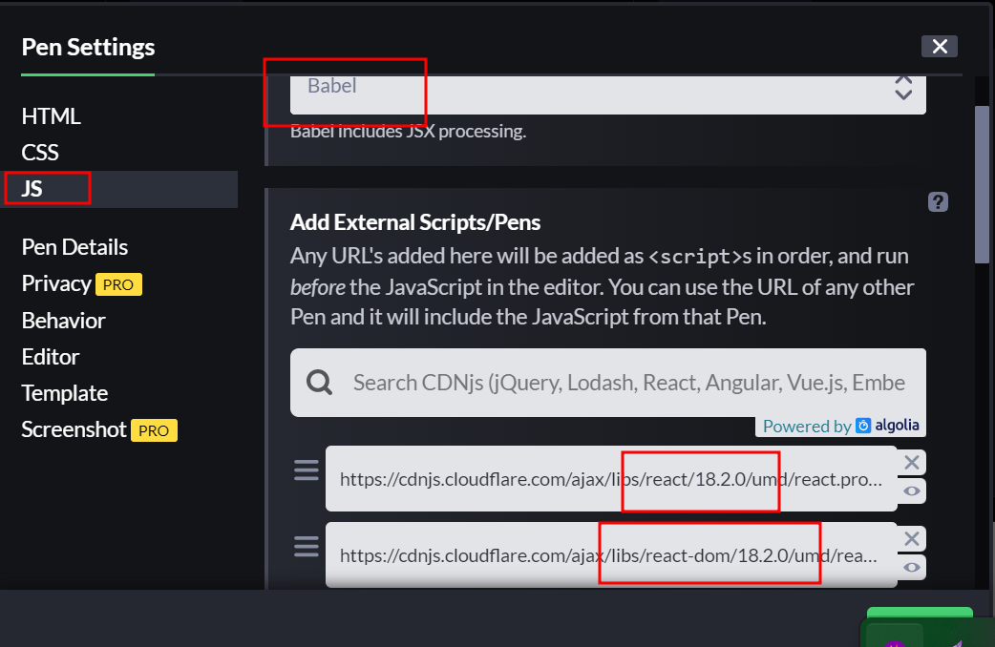

In React JS we will create the React Component using function style as well as class style.

React Component is use to control the view or part of the view in web page.

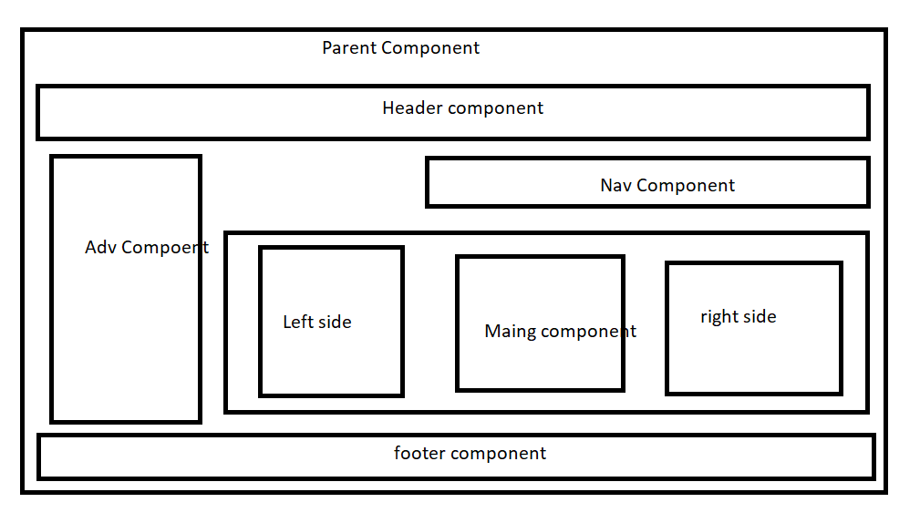

Using React Component we are creating user defined tag.

<p></p>

<div></div>

<font></font>

In React Using component we are creating user defined tags.

To create the react JS Project we need to install Node JS.

Node JS : Node JS is a run time environment for JavaScript program or JavaScript library or JavaScript framework. Like JRE in Java

Before Node JS JavaScript is known as Client-Side Scripting language. Means that that JavaScript language we can develop application using browser. Because provide parser to check the script tag.

Before node JS if we want to develop server side programs we were depends on other programming language like Java (Spring or spring boot), asp.net, php, python etc.

After Node JS we can say JavaScript also known as server side scripting language.

Node JS provided lot of modules which help to create server side programming, rest api , connecting database like mysql or mongodb, security etc.

Using Node JS we can run External JavaScript code using command prompt.

Node Js provided internal command ie npm (node package manager) which help to download external module like mvn

npm --version

npm install -g modulename

npm install -g create-react-app

create-react-app it third party node module which help to create react js project.

After installed successfully

Please check create-react-app version using command as

create-react-app --version

Node JS Install 16

Node --version

Npm –version

Using npm install -g create-react-app

create-react-app --version

Then you can create the React js project

So create react program folder and open the command prompt inside that folder

Then run the command as

create-react-app project-name

Example : create-react-app demo-app

Day 7 :

05-23-2023

create-react-app welcome-app

cd welcome-app this command is use to move inside a project folder

or Example cd project-name

cd demo-app

npm start this command is use to run the react js project.

The project get compiled and run on default browser with port number 3000 using URL as

<http://localhost:3000>

now please open this project in VSCode IDE.

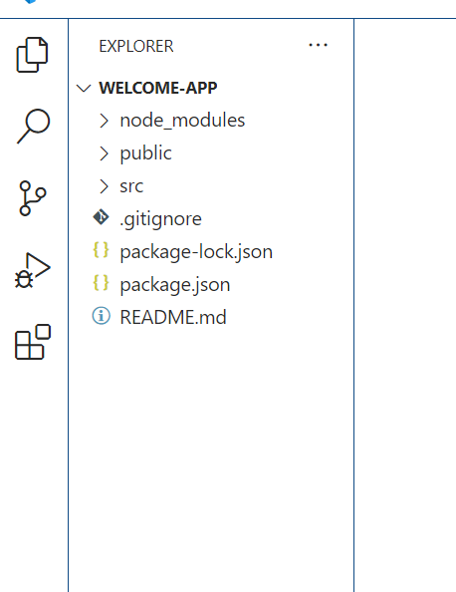

node_moduels

public

src

And set of files

Inside src we can see set of files

App.js

If we write any component in another file we need to export that component so

In another file we can import this component export and import is like a package in java.

We create the component in function style.

Now we will create the component in class style.

In function style as well as class style we return html code with help of JSX in react component.

In SPA application every component for specific purpose. So in, component if want to describe the component behaviour or functionality we have to use react component variable.

In React Every component hold two types of variable ie state and props.

If we want to describe react component behaviour we need to use state variable. We can change the value of state variable So static variable is known as mutable. (can change)

If we want to pass the value from one component to another component we need to use props variable. We can’t change the props variable value so props is known as immutable. (can’t change)

In Class component we can use state variable that purpose class component generally known as state full component.

In function component we can’t use state variable so function component is known as stateless component.

But from React 16.x version onward we can use state variable in function component with help of react hook.

App is parent component

Employee is child component.

<html> parent component, head, and body are child tag

<head>

</head>

<body> p is child for body tag.

<p></p>

</body>

</html>

<p>

<body></body>

</p>

Or

<body>

<p></p>

</body>

Creating state variable in function components.

To create state variable in function component we need to use hook

Ie useState() pre defined function. This pre defined function part of react we need to import is

import useState from ‘react’;

In class component we can change state variable using setState() functions with or without events.

If we want to change state variable which we declare in function component using react hook then we need to follow syntax as

let [variableName,setFunctionName]=useState(defaultValue);

React JS Events.

React JS support same event provided by JavaScript.

But in JavaScript we use function name to handle that events in

React JS we need to use JSX syntax to handle that events.

In JavaScript Events.

<input type=”button” value=”Click Here” onClick=”info()”/>

In React JS Events in Function style

<input type=”button” value = “Click Here” onClick={info}/>

create-react-app react-forms

create-react-app product-management-system

Day 8 :

05-24-2023

JSX : JavvaScript and XML

create-react-app jsx-concept

cd jsx-concept (move inside a project folder)

then open jsx-oncept folder in vs code

to start the project npm start

html provided lot of pre defined tags

ie

p, div, span and those tag can be understand in every browser.

MyTag, EmployeeTag,CustomerTag etc.

<p>Welcome to HTML Page</p>

<h1>Welcome to HTML page</h1>

<MyTag></MyTag>

function MyTag() {

return <div>Welcome to MyTag</div>

}

Ternary operator

Let result = condition?trueblock:falsebock;

var a=100;

var b=20;

let result =a>b?”a is largest”:”b is largest”;

node --version

npm –version

create-react-app this command is use to create the react js project.

This enable create-react-app command we need to execute below command.

npm install -g create-react-app

create-react-app project-name (this command is use to create react js project)

example

create-react-app react-forms

once project created

please move inside project folder using command as cd react-forms

to run the project we need to run the command as

npm start it automatically open in default browser with url as

<http://localhost:3000>

create new project with name

create-react-app product-management-system

Day 9:

05-25-2023

React JS with styling

All CSS property in react js follow camel naming rules.

In Normal CSS

background-color:”yellow”

Inline CSS in html with CSS

<h1 style=”background-color:yellow”></h1>

In react JS this property is replaced by

backgroundColor:”yellow”;

<h1 style={{backgroundColor:yellow}}></h1>

App.css

.myClass {

  background-color: blueviolet;

  font-size: large;

  color: white;

}

In Every component import this file using command as

Import ‘./App.css’

Then use with className attribute

<div className=”myClass”></div>

By default in React JS

App.js file contains App component created using function style.

That component is parent component consider.

Index.js file

Provide bridge between react component and actual dom with help of ReactDOM.render()

ReactDOM.createRoot(document.getElementById("root")).render(<App/>);

It will render to index.html page insider div with attribute as root.

Index.html page present inside public folder.

In React index.html is first page consider.

So if we want to add bootstrap features for react.

One of the way please bootstrap CDN url insider index.html page

And every component you can use all bootstrap class inside a tag

With attribute name as className

To enable bootstrap features add bootstrap in index.html page between head tag.

  <link href="https://cdn.jsdelivr.net/npm/bootstrap@5.0.2/dist/css/bootstrap.min.css" rel="stylesheet" integrity="sha384-EVSTQN3/azprG1Anm3QDgpJLIm9Nao0Yz1ztcQTwFspd3yD65VohhpuuCOmLASjC" crossorigin="anonymous">